CSE-326

HTML PROJECT- MARKETING WEBSITE

Names: Chirag , Ashi Gupta , Sravyanjali Damodarapatruni

Roll numbers: 38 , 39 , 40

Our company name is “ASC”. We as a group have designed a marketing website specifically a cloth marketing website using HTML applications.In the website there is women , men , kids and studio section, where we can search the item and buy it. We can also visit user profile , add items to wishlist and bag.The website also includes the location and phone number in case of query , exchange of items purchased.

HTML (Hyper Text Markup Language) is the code that is used to structure a web page and its content along with CSS and Javascript .

The following html program also includes the use of CSS . The tags used in the code are:

* Meta tag-It is an empty tag, <meta>tag defines the metadata of a Html Document.
* List Tag- The <li> tag defines a list item.
* Division tag- The <div> tag defines a division or a section in an HTML document.

Link Tag- The <link> tag defines the relationship between the current document and an external resource.

* Table Row- The <tr> tag defines a row in an HTML table.
* Table Head- The <th> tag defines a header cell in an HTML table.
* Table d-The <td> tag defines a standard data cell in an HTML table.
* Table Body-The <tbody> tag is used to group the body content in an HTML table.
* Section Tag-The <section> tag defines a section in a document.
* Paragraph Tag-The <p>  tag defines a paragraph.
* Navigation Tag-The <nav> tag defines a set of navigation links.
* Image Tag-The <img> tag is used to embed an image in an HTML page.
* Header Tag-The <header> element represents a container for introductory content or a set of navigational links.
* Heading Tag-The <h1> to <h6> tags are used to define HTML headings.
* Doctype Tag- <!Doctype> It is an "information" to the browser about what document type to expect.
* Body Tag-The <body> tag defines the document's body.

OUTPUT :

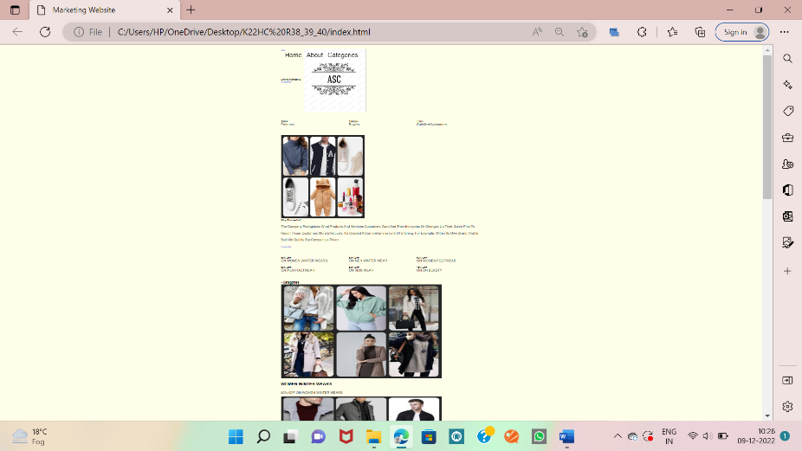

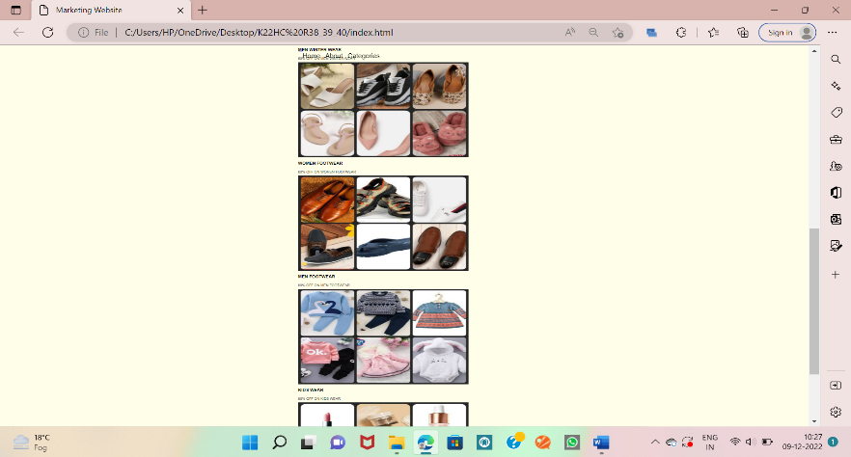

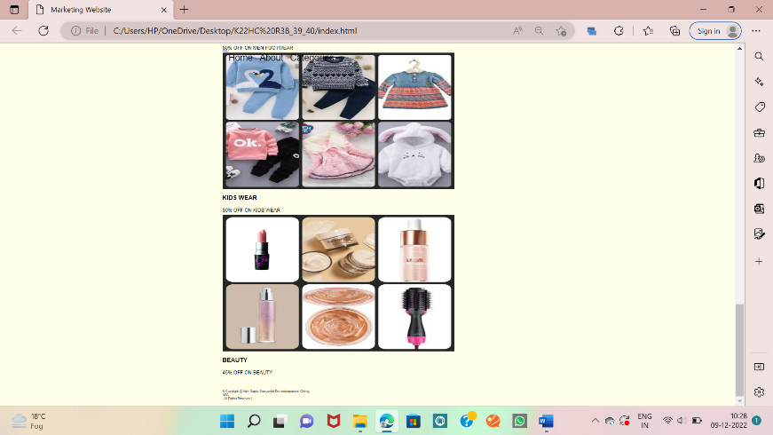

LOGO:

